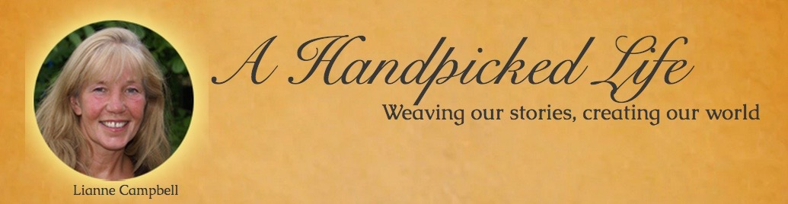

Daily pleasures – week three

Day Fifteen - Breathe in Gratitude

Combine deep breaths with gratitude today. At least three times bring something to mind that you feel really grateful for and take three fully conscious breaths, breathing that gratitude deep into your lungs, allowing the feelings to penetrate through every cell of your body. There is no right way to do this, the intention of letting it penetrate is enough.

Day Sixteen – Take a Long Bath or Shower

Take a bit of extra time today to enjoy a luxurious bath or shower, really feel the warm water on your skin as you slide into your scented bath or the freshness as the water cascades over your face and body in the shower. Light candles, have music, cater to your own taste.

Day Seventeen - Wear Something Different

Wear something you wouldn’t normally wear, be bold, combine your clothes in a way that you wouldn’t normally and don’t ask anyone if you look ok. Just do it!

www.liannecampell.com

Day Eighteen – Clear Something Out

This can be a big job like that pile of clothes you keep looking at, or that small drawer in the bathroom that is full of bits of old soap you will never use, or even that tiny basket full of…well who knows what’s in there; take a look and see what you are storing. Choose something, clear out and re-organize.

Day Nineteen - Smile More

Simply that: wake up and smile, smile at the dog, the mail, the toothpaste without the top on (again), the kettle, yourself in the mirror. Just smile.

Day Twenty - Gratitude Shower

Time to immerse yourself in the glory of all that is great and good in your life. Make it all different again (ok you can mention two things you wrote down last week, the rest can be different from the previous. Indulge and enjoy it)!

www.liannecampbell.com

Day Twenty One - Check In

1. Journal - What worked for you this week? Did you feel lighter at the end of your breathing in gratitude day? What was wonderful about choosing to consciously enjoy and add tsomething to your regular bathing ritual? Did you enjoy creating a new outfit? How did you feel after clearing out (even if it only was that tiny basket)? Are you still smiling? How is your daily practice going? What benefits are you feeling? Did you enjoy your ‘favourite date’?

2. Choose two or more pleasures and combine for today.

3. Choose another favourite and make time for it this week.

www.liannecampbell.com

